Damar Zaky – 1301164460

The problem that I’m trying to solve here is to determine the top 20 family head who deserve to get BLT. To determine it, we have data of each family, which is income and debt. With these attributes, we can make a fuzzy logic system to make a score of each row based on those attributes.

**Design**

**Fuzzy rules**

|  |  |  |  |
| --- | --- | --- | --- |
| very high | accepted | accepted | considered |
| high | accepted | accepted | rejected |
| low | accepted | considered | rejected |
| very low | considered | rejected | rejected |
| debt/income | low | medium | high |

**Membership Function**

Based on the data the maximum value of income is 1.9, while the minimum value is 0.11199999999999999, then the maximum value of debt is 98.0, while the minimum value is 0. From that I conclude that low income is below 0.4 and from 0.4 to 0.8 is the fuzziness. Medium income starts as fuzziness from 0.4 to 0.7 then from 0.7 to 1.3 is medium and from 1.3 to 1.4 is the fuzziness. High income is 1.5 with fuzziness starts at 1.1.

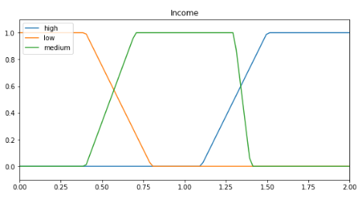

Very low debt is below 15 and fuzziness starts at 30, low debt fuzziness starts from 20 to 32, while 32 to 48 is considered low, and 48 to 59 is the other fuzziness. High debt fuzziness starts from 50 to 60, while 60 to 70 is considered high, and 70 to 78 is the other fuzziness. Very high debt starts from 77, while the fuzziness starts from 64.

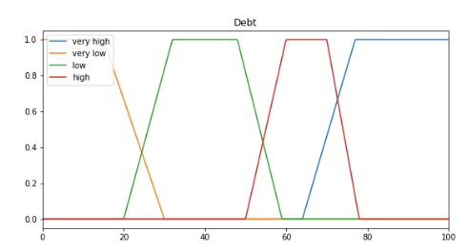

**Analysis**

I use this formula to define fitness: income/debt, and the less the results, the more likely to get BLT.

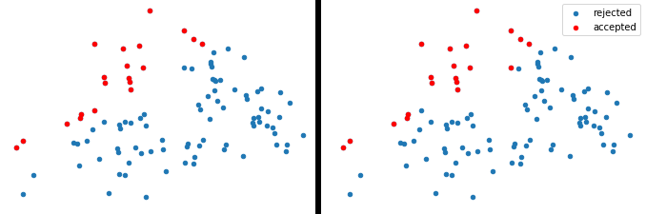

The left plot is the result based on the fitness formula, while the right plot is the result based on my fuzzy logic parameters. If you compare it to the fuzzy rules table design I made above, you can also conclude that the more to top left the data on the plot, the more likely it to be accepted.